**PF THEORY ASSIGNMENT# 2**

**QUESTION NO 1:**

1. INTEGER
2. LONG INTEGER
3. CHARACTER
4. FLOAT
5. INTEGER
6. INTEGER
7. DOUBLE FLOAT

**QUESTION NO 2:**

1. Its answer is 0.0 because 2 and 7 are integer or given d is a float.
2. 7%2=1 so x=-1-8= -9, BECAUSE WE GIVE PRIORITY TO MODULAS FUNCTIONS SO 7%2=1 SO -1-8=-9.
3. By solving both side if we solve L.H.S IT GIVES 0 BECAUSE OF & OPERATOR OR BY SOLVING R.H.S WE GET 1 SO 0!=1

THE GIVEN CONDITION IS TRUE SO IT WILL PRINT ‘1’.

1. 3+4=7 so a=7, b=7, c=7, simply plus them.
2. Y=z -3%-8=-3 so = -3/2+7== ‘5.5’ OR ‘6’

because in float it gives 5.5 but in integer it gives 6.

So y=6, z=6.

**QUESTION NO 3:**

**FLOW CHART:**

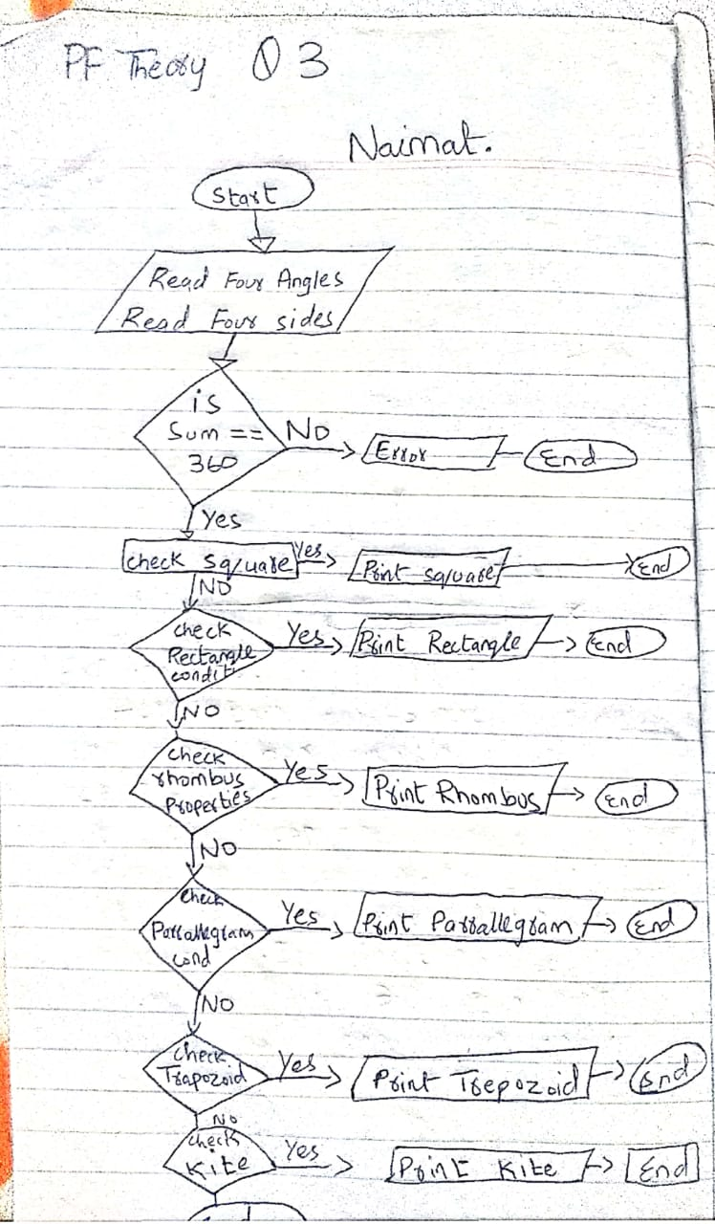

**INPUT:**

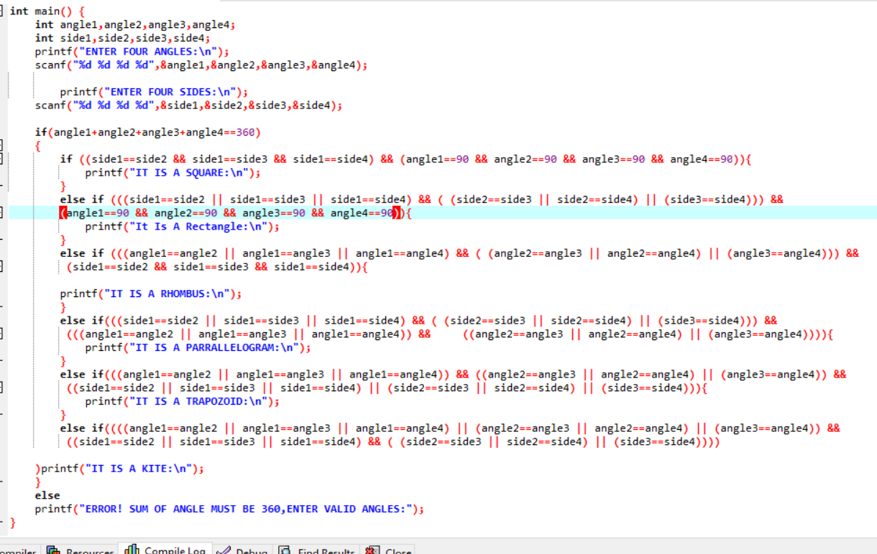

**OUTPUT1, 2:**

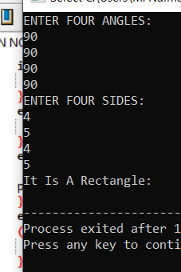

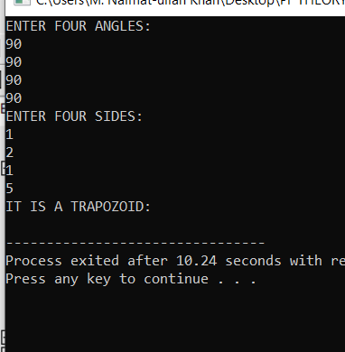

**QUESTION NO 4:**

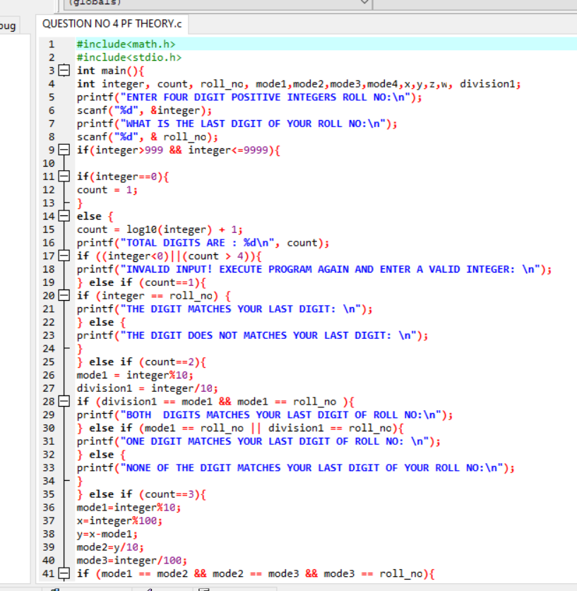

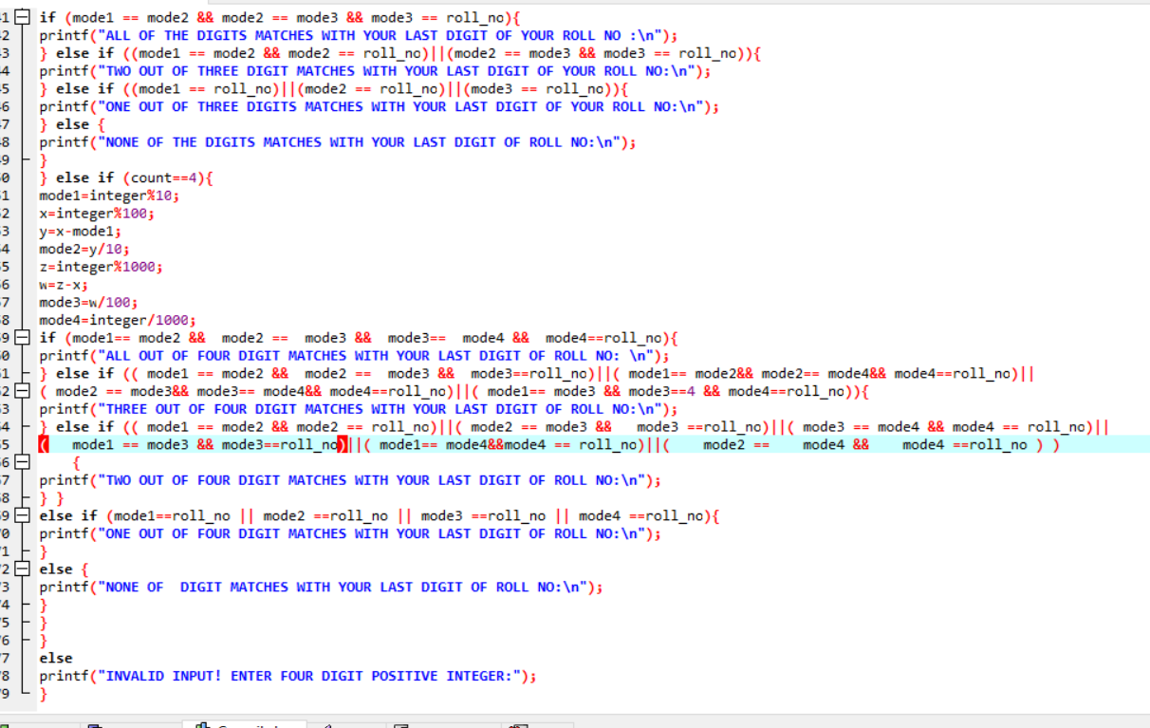

**OUTPUT 1, 2:**

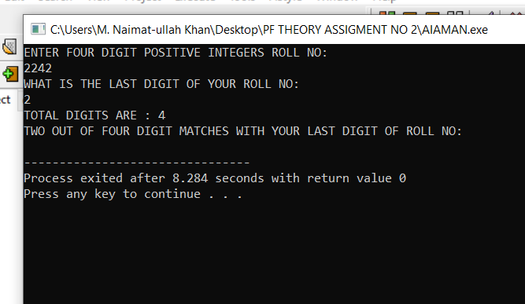

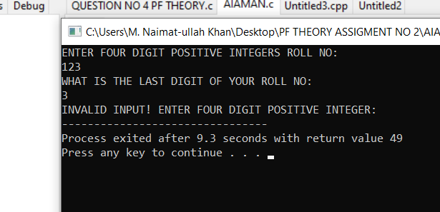

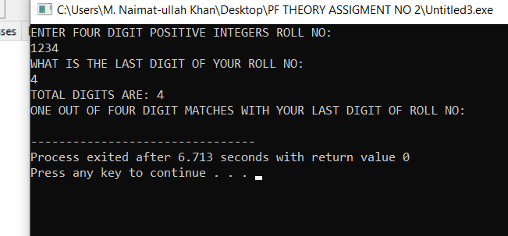

**QUESTION NO 5:**

**PART A:**

**THE ANSWERS ARE:**

**W= 1, X=0, Y=1, Z=1.**

**THE LIBRARY IS MISSING,**

**#INCLUDE<STDIO.H>**

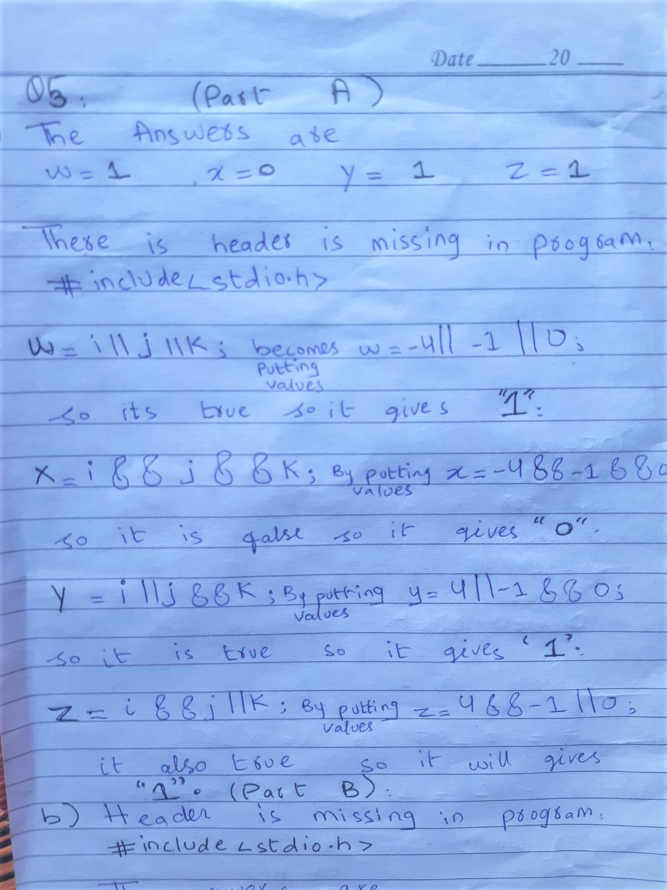

**PART2:**

**THE LIBRARY IS MISSING,**

**#INCLUDE<STDIO.H>**

**The answers are:**

**K=0, l=2, a=0.000000, b=2.000000.**

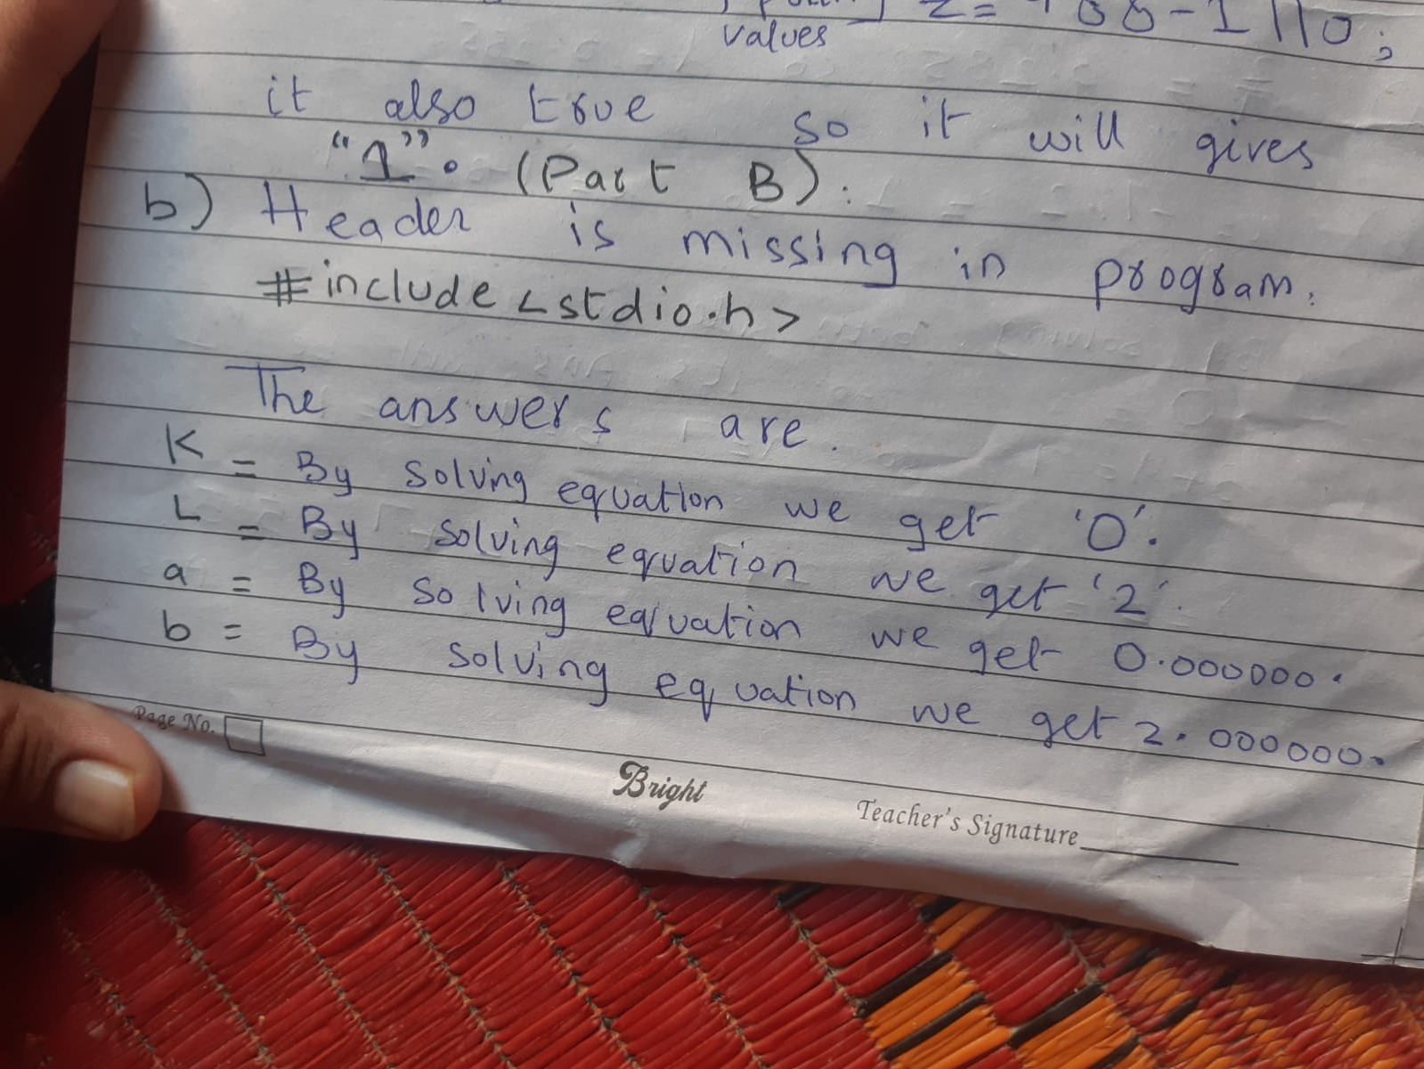

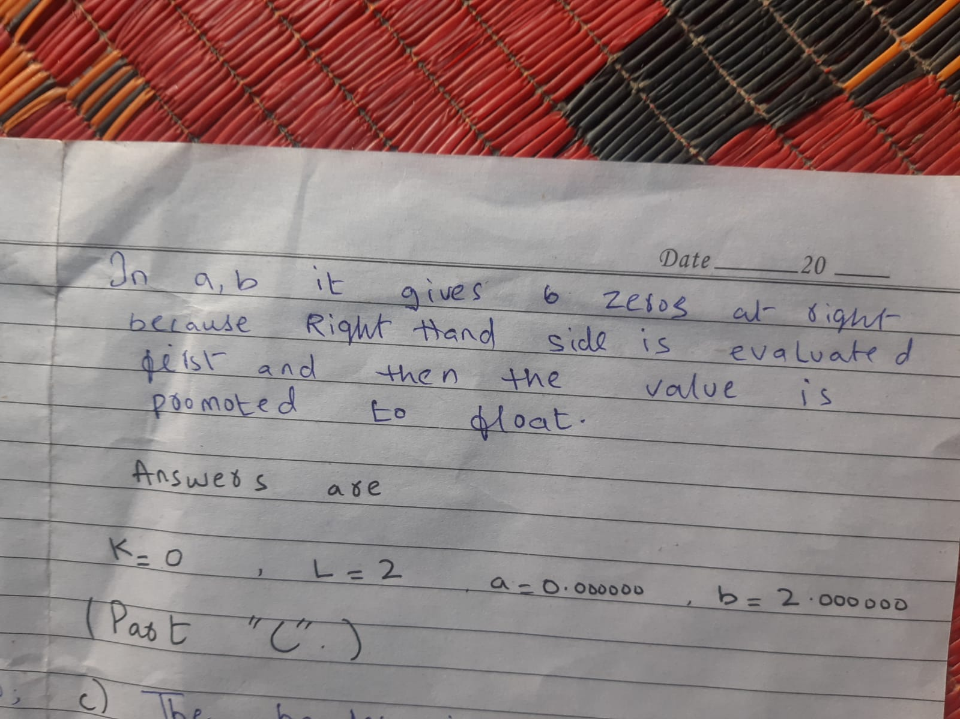

**PART ‘C’:**

**THE LIBRARY IS MISSING,**

**#INCLUDE<STDIO.H>**

THE ANSWERS ARE:

A=1, B=-18

IN PRINTF FUNCTION LINE WE HAVE TO USE %d INSTEAD OF %f.

Both m, n are integer for integer we use %d 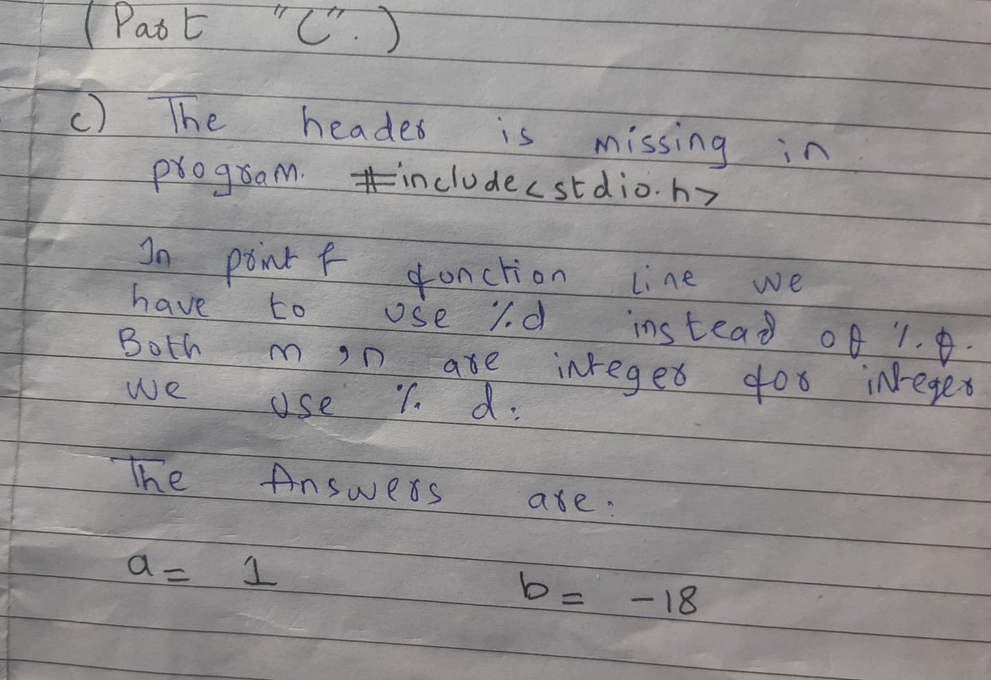

**QUESTION NO 6:**

**INPUT:**

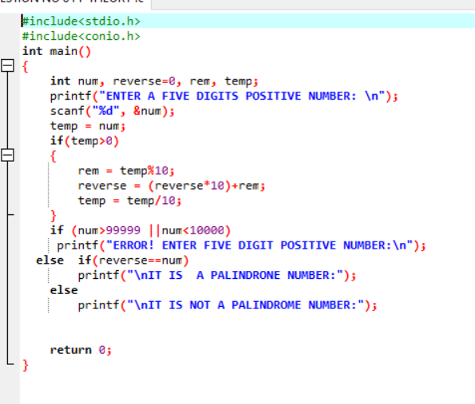

**OUTPUT:**

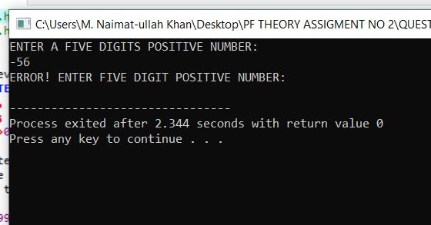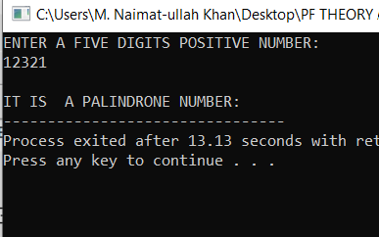

**QUESTION N0 7:**

**ALGORITHEM FOR IT:**

1. PROMPT AND GET FOUR POINTS OF A LINE AS AN INPUT FROM THE USER.
2. FIND THREE SLOPE OF A GIVEN FOUR POINTS USING SLOPE FORMULA:

* slope1= (y2-y1)/(x2-x1)
* slope2= (y3-y2)/(x3-x2)
* slope3= (y4-y3)/(x4-x3)

1. IF SLOPE1=SLOPE2=SLOPE 3 USER WILL GET ALL THE POINTS FALL ON A STRAIGHT LINE.
2. IF SLOPES ARE NOT EQUAL USER WILL GET ALL THE POINTS DOES NOT FALL ON A STRAIGHT LINE.

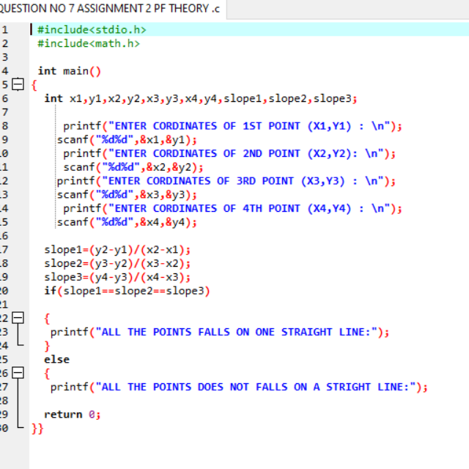

**Output:**

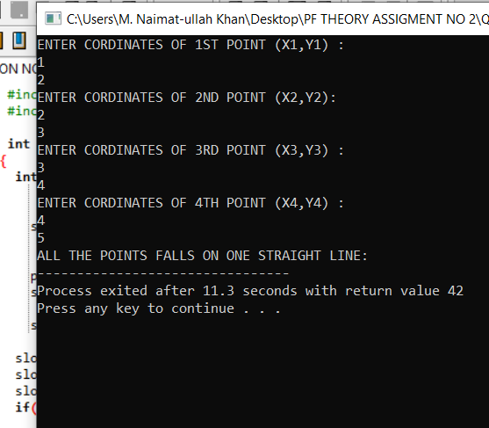

**Question 8:**

**Input:**

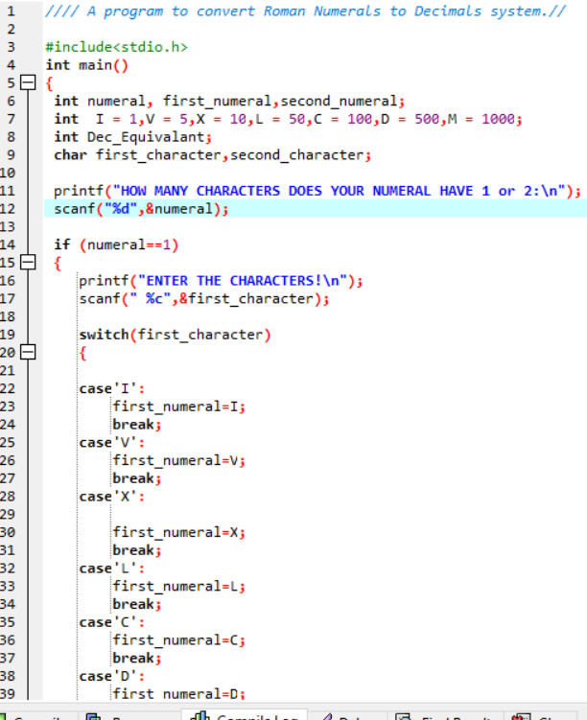

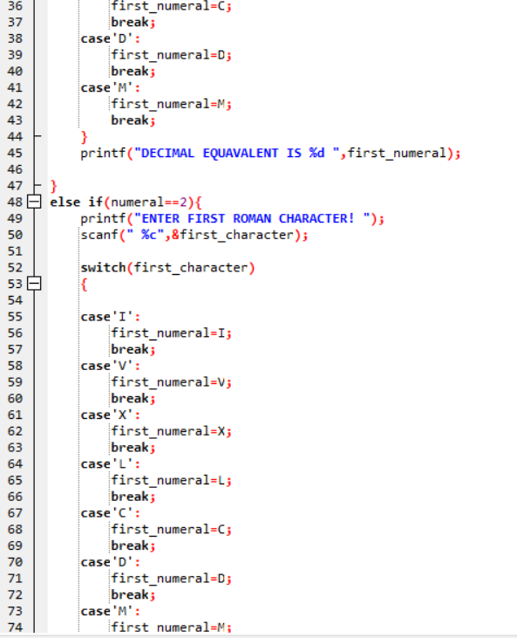

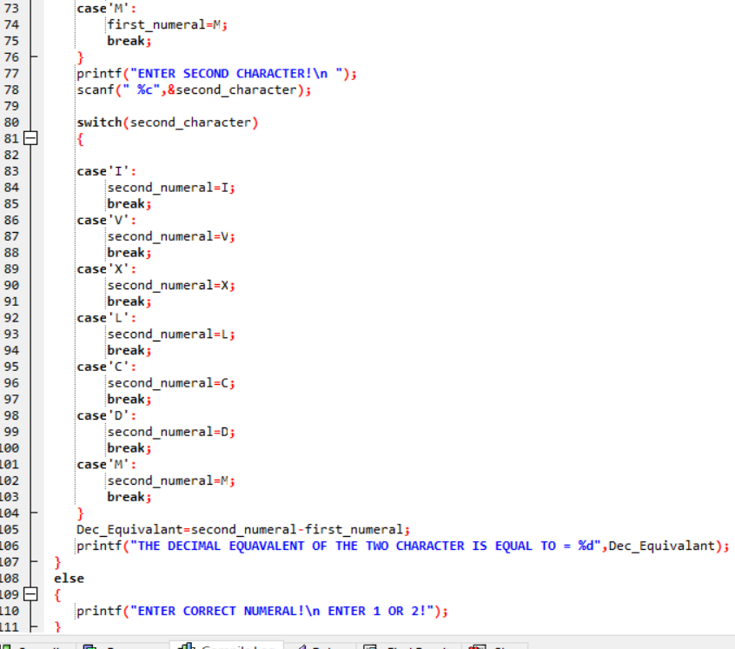

**Output:**

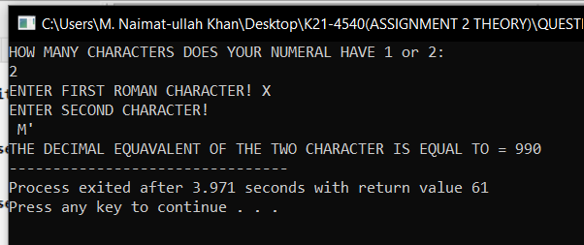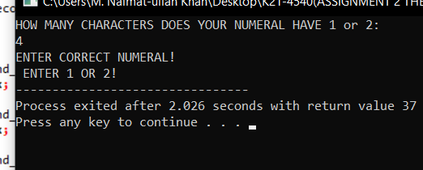

**QUESTION NO 9:**

**ALGORITHEMS:**

1. PROMPT AND GET TWO DIGIT NUMBER INPUT FROM THE USER.
2. DECLARE 8 BITS WITH NAME DIGIT1, 2, 3, 4, 5, 6, 7, 8 .
3. IF NO IS >9 OR < 100 SO CONVERT INTO BINARY.
4. TAKE MODULAS OF THE NUMBER BY 2 LIKE; DIGIT1=X%2; THEN DIVIDE THE NUMBER BY 2.
5. INITIALIZE ANOTHER VARIABLE WITH NAME X1 AND THEN APLLY THESE METHODS FOR DECIMAL TO BINARY CONVERSION.LIKE;

* digit2=x1%2;
* x1=x1/2;
* digit3=x1%2;
* x1=x1/2;
* digit4=x1%2;
* x1=x1/2;
* digit5=x1%2;
* x1=x1/2;
* digit6=x1%2;
* x1=x1/2;
* digit7=x1%2;
* x1=x1/2;
* digit8=x1%2;
* x1=x1/2;

1. AFTER APPLYING ALL THESE YOU WILL GET BINARY VALUE SO IF YOU WANT TO CONVERT THE RESULTANT BINARY BACK TO ITS ORIGINAL DECIMAL YOU HAVE TO USE IF STATEMENT LIKE;

* (digit8 & 1)
* sum+=128

1. YOU JUST HAVE TO CHANGE THE DIGIT IN REVERSE ORDER AND INCREMENT ITS SUM BY 1 OR ALSO IN IN 8 DIGIT TOTAL 128 BITS STORES SO EVERY TIME YOU REVERSE THE NUMBER DIVIDE THE BIT BY 2 LIKE;

* (DIGIT5 & 1)
* SUM+=16
* REVERSE THE ORDER AT THE END YOU WILL GET 1 SO
* (DIGIT1 &1)
* SUM+=1

8. AFTER ALL STEPS YOU WILL GET DECIMAL EQUAVALENT OF RESULTANT BINARY:

9. PRINTF HURRAH YOUR PROGRAM IS CORRECT ON THE SCREEN:

**INPUT:**

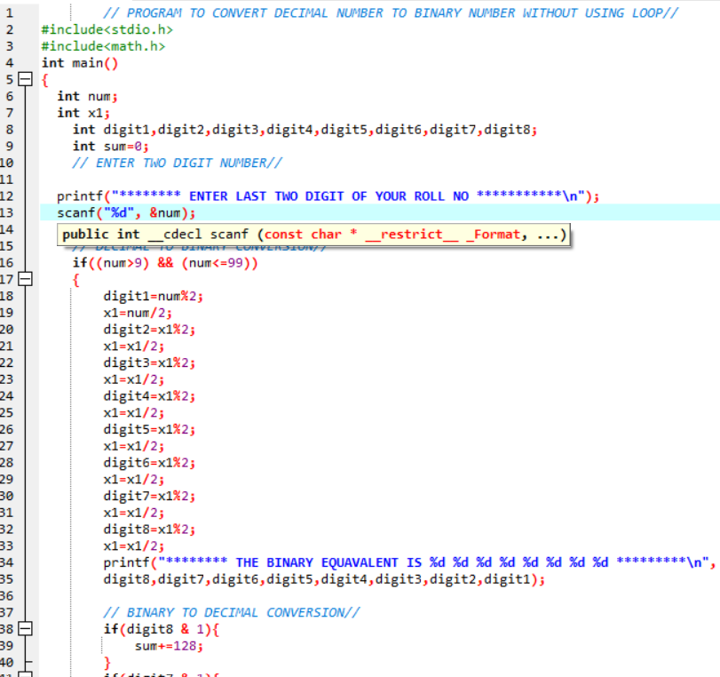

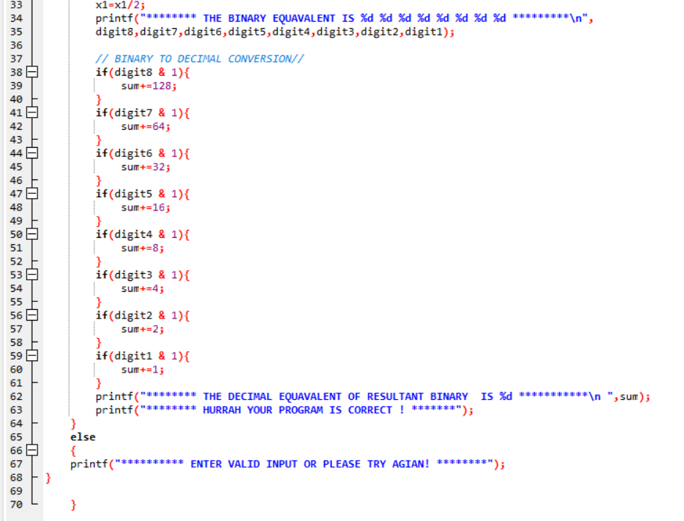

OUTPUT:

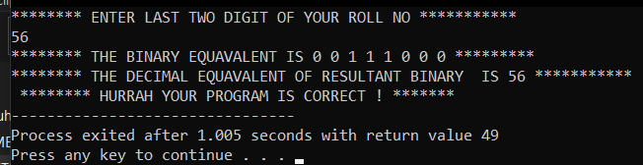

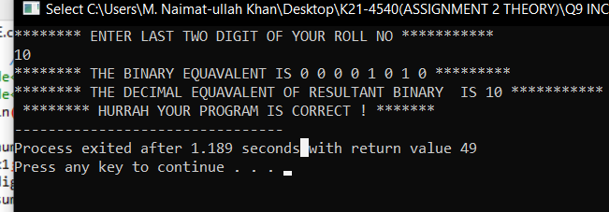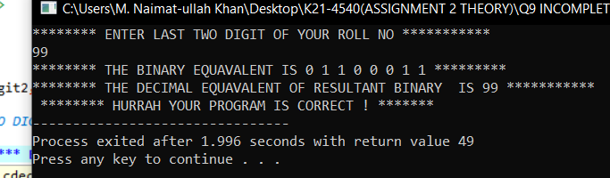

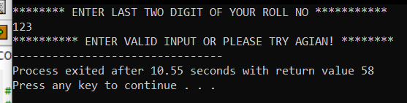

**QUESTION NO 10:**

**FLOW CHART:**

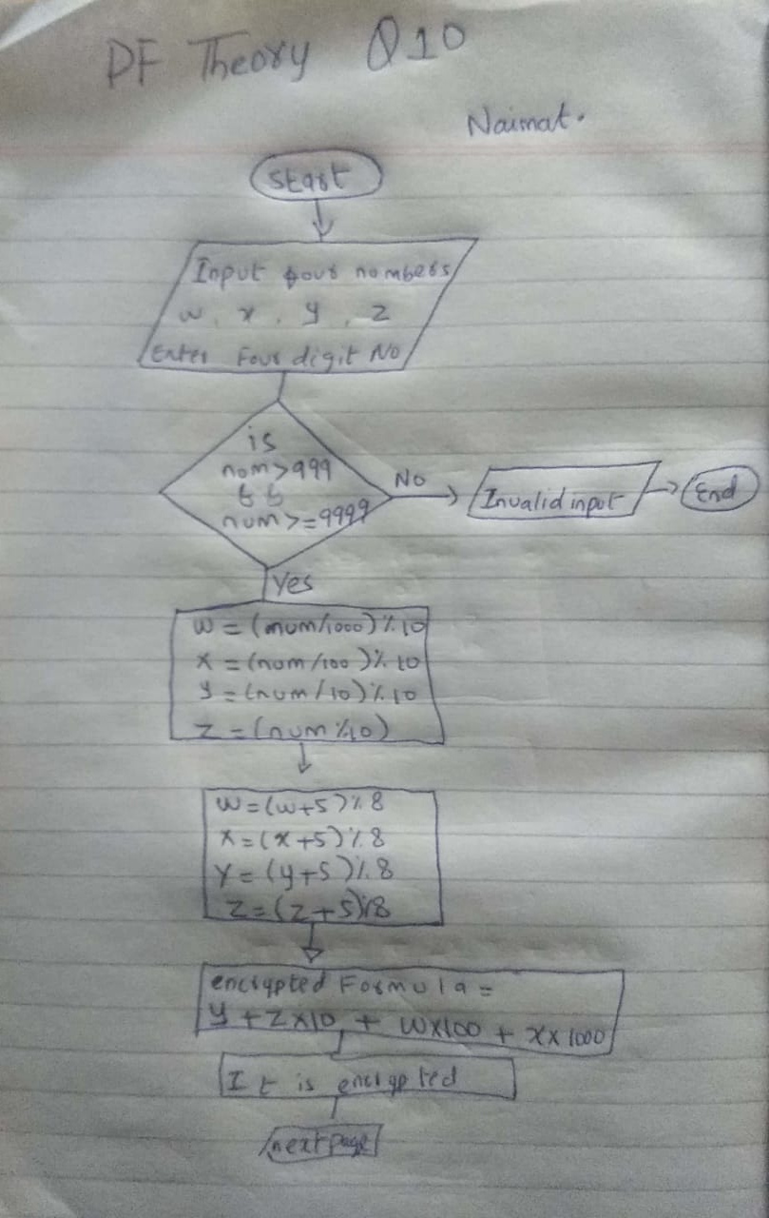

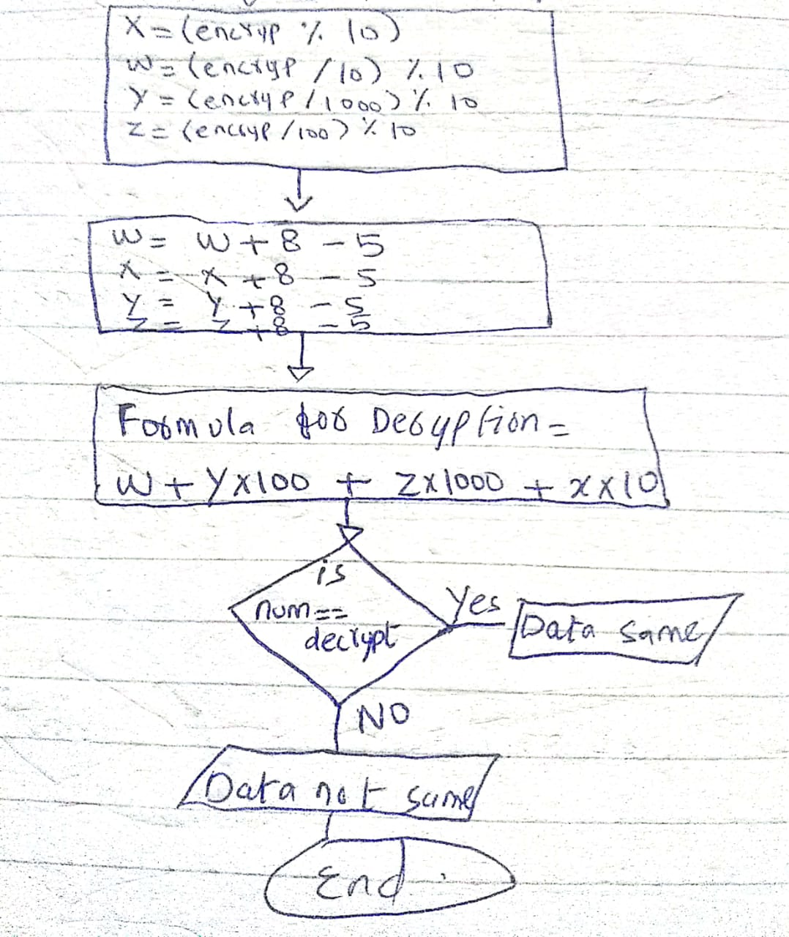

**INPUT:**

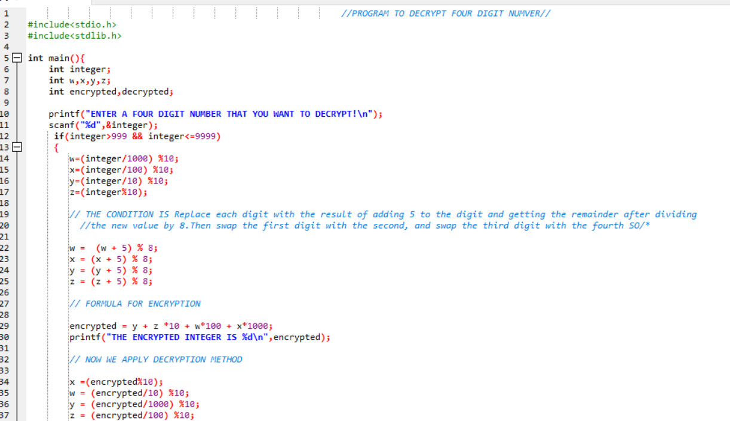

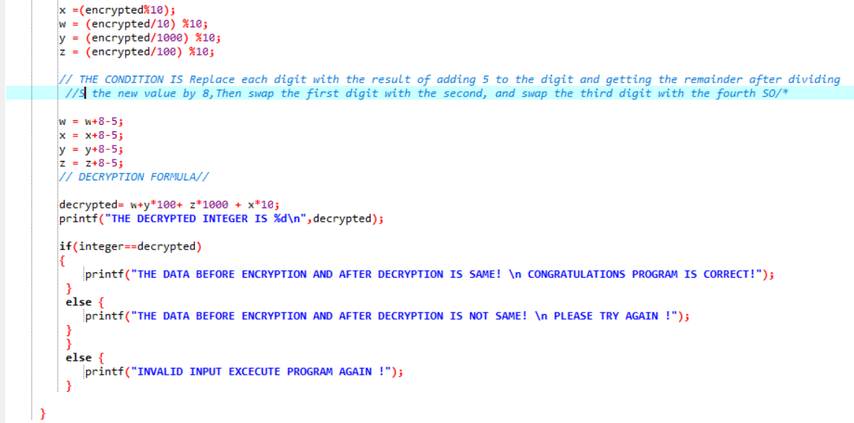

**OUTPUTS:**

